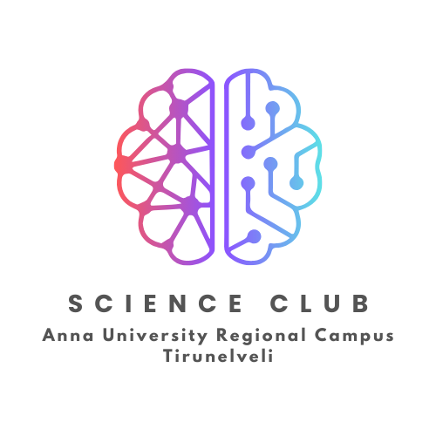

***Prelude***

Science Club is the platform for the students to promote their scientific interest, realize their scientific skills and fulfill their quest in doing science activities. To inculcate the scientific temper among the students and society is an essential activity of this club with science popularization talks, visit to scientific places, etc. Further, the club aims to organize Seminars, Workshops, Exhibition and Quiz competition to instill students knowledge and skill in the field of science.

***Objectives***

* To inculcate scientific attitude among the students
* To provide opportunity for the development of the constructive, explorative & inventive ideas among the students
* To develop the training in scientific method of problem solving
* To develop students, interest and participation in the practical applications of the knowledge related to different branches of sciences

***Modalities from University***

As per the Regulation 2021, clause 4.2 (and earlier regulations), all the students shall enroll in any one of the personality and character development programmes, namely, NSS / NSO / YRC / Literary Club / Science Club and undergo training / conduct of activities for about 80 hours and attend a camp / event. *Further, the same clause 4.2 states as follows:*

*“****Science Club*** *shall organize activities of popularization of science and scientific temper through activities related to astronomy, works of great scientists from India and abroad, observing National Science Day, etc.”*

***Programs organized***

* **Inauguration of Science Club** during the academic year 2023-24
  + - *The Science Club was established with the approval of Honourable Vice-Chancellor of Anna University as per the Regulation-2021. Subsequently, the club was inaugurated by the Dean of the campus and the logo for the Science Club was released.*
* **KALAM'24 - a Science Fair** - state level UG intercollegiate program organized on 22.03.2024
  + - *A science expo and paper presentation event for the UG students across the state was conducted as per the approval of the Honourable Vice-Chancellor as part of the Science Club activity. Students across the state registered with their innovations with 60 project expeditions and 123 paper presentations both in English and Tamil. The event was conducted in successful manner and the participants were provided with their certificates and appreciations.*

*First prize of the project expo was awarded with the cash prize of Rs.6000/- and second prize with Rs.3000/-. Further, the first and second prizes for the paper presentations were honoured with cash prize of Rs.2000/- and Rs.1000/- respectively in English and Tamil individually. The Head, District Science Center, Tirunelveli has addressed the participants with his enlighten speech about Future Science and Technology and distributed the cash prizes and certificates.*

* **Astronight - Sky watching** - in collaboration with District Science Center, Tirunelveli the event of sky watching is successfully organized the dawn of a day with the powerful telescope by introducing the sky in close proximity by identifying various planets, stars and celestials. Students and staff members witnessed the event with their family and friends with great joy.

|  |  |
| --- | --- |
|  | Faculty In-Charge for Science Club  **Dr. J. Judes**  Assistant Professor (Physics), Dept. of S & H |

Follow us on: @Science_Club_AURC_TVL

Contact us on: scienceclub.aurct@gmail.com